Mini Project On:

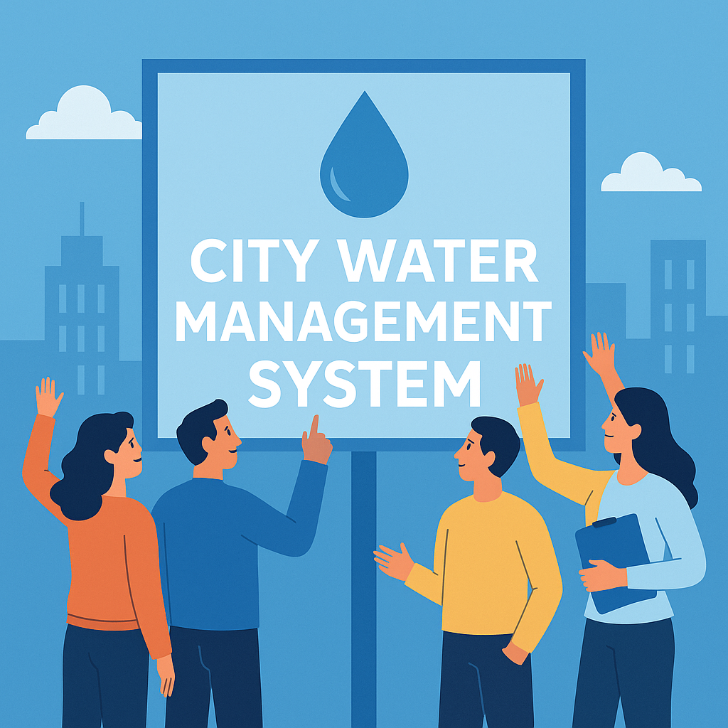

Title: City Water Management System

Submitted by:

Name: Vundela Sravan Sri Siva Kumar Reddy

Sec: CSE_C

Roll No: NC.SC.U4CSE24237

For

23CSE111- Object Oriented Programming

II Semester

B.Tech. CSE

Submitted to:

Name: Dr. V. Thanammal Indu, Assistant Professor

Course Title: Object Oriented Programming

Course Code: 23CSE111

|  |  |  |
| --- | --- | --- |
| **Sl.No.** | **Chapter Name** | **Page No.** |
| 1 | Introduction | 3 |
| 2 | Problem Statement | 4 |
| 3 | Objectives | 5 |
| 4 | UML diagrams of the project   1. Class Diagram 2. Use-Case Diagram 3. Activity Diagram 4. Sequence Diagram | 6-9 |
| 5 | Modules of the project | 10 |
| 6 | Code |  |
| 7 | Output Screenshots |  |
| 8 | Application of the project |  |
| 9 | Limitations of the project |  |
| 10 | Bibliography |  |
| 11 | GitHub link of the project |  |

**Index:**

Introduction:

Water is a natural resource, and sustainable management of the same has become a global concern of great importance. With growing population, urbanization, and global warming, efficient use of water and its conservation have become an unprecedented requirement. To counter the above issues, the Smart Water Management & Conservation System has been created.

The project will give an online platform where the public and the authorities can track and manage water usage in different cities. The system provides a mechanism to input data pertaining to water usage and update the total water availability, enabling effective monitoring of resource utilization. It enables transparency and awareness with real-time city-wise water availability.

With server-side logic using Java, client-side user interfaces using HTML/CSS, and database storage using MySQL, this system provides smooth interaction and precise data control. Instant client-side updating is done using Local Storage. Simplicity in the interface provides community engagement, and backend integration provides intelligent analytics and government-grade decision-making for water resource management.

In conclusion, the system acts as a starting point for encouraging the use of water sustainably, compelling communities to keep their use in mind and to support conservation efforts.

Problem Statement:

1. The growing rate of water scarcity is a key worldwide problem caused by fast-growing urbanization, increasing population levels, and poor utilization of water resources. The majority of urban cities experience poor timely information on water supply and use, leading to overexploitation, misallocation, and wastage of water resources.
2. Additionally, the general public is often oblivious to the current water situation in their area, and regulatory bodies cannot monitor and manage water usage in the absence of a centralized data-driven system.
3. There is a great demand for a smart system that not only monitors and displays water consumption and availability at the municipal level but also allows users to enter data and update records of availability, thus allowing proper monitoring and strategic conservation.
4. The Smart Water Management and Conservation System aims to respond to this problem by suggesting a web-based approach where:
5. The residents can provide their water usage.
6. Total water supply for every city can be refreshed and reset by authorities or users.
7. The system holds and presents current, city-level water information.
8. This framework helps link users with authorities to ensure efficient, open, and sustainable management of water resources.

Objectives:

**1.Monitor Water Usage:**

* Enable users to submit their daily or periodic water consumption by city.
* Track cumulative water usage data for better insight and reporting.

**2.Manage Water Availability:**

* Allow administrators or users to enter and update the total water availability for different cities.
* Provide a mechanism to reset or adjust water availability values as needed.

**3.Real-Time Data Representation:**

* Display current water availability in various cities using a user-friendly interface.
* Ensure the information is updated instantly after each transaction (submission or reset).

**4.Promote Public Participation:**

* Encourage citizens to contribute to the system by reporting their water usage.
* Raise awareness about water conservation through visual and interactive tools.

**5.Support Decision-Making:**

* Offer insights that help governing bodies and planners make informed decisions about water distribution and conservation policies.

**6.Ensure Transparency and Accountability:**

* Maintain transparent records of water usage and availability to avoid misuse or unreported consumption.

**7.Provide a Scalable Web-Based Solution:**

* Design the system to accommodate more cities and users as needed.
* Build a responsive and easy-to-navigate frontend for both public and administrative use.

UML diagrams of the project:

1.Class Diagram:

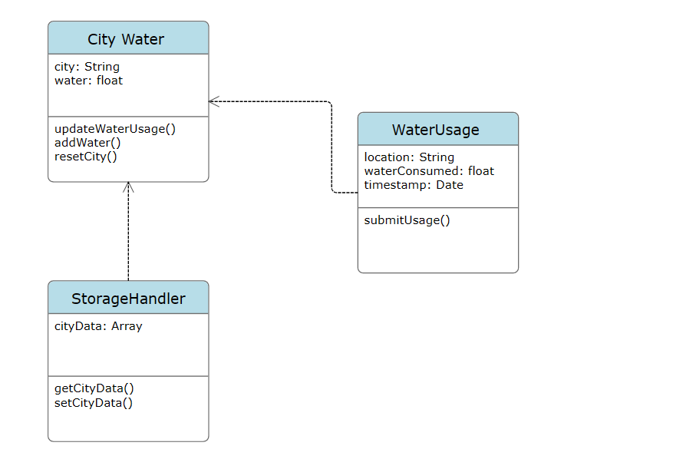

2. Use-Case Diagram:

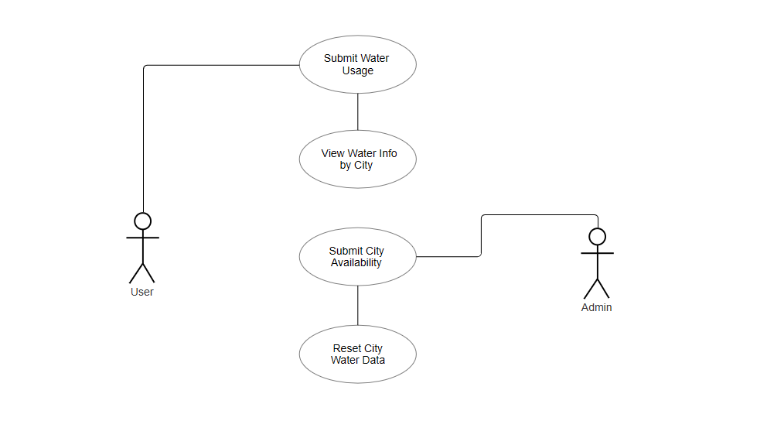

3.Activity Diagram:

User Activity:

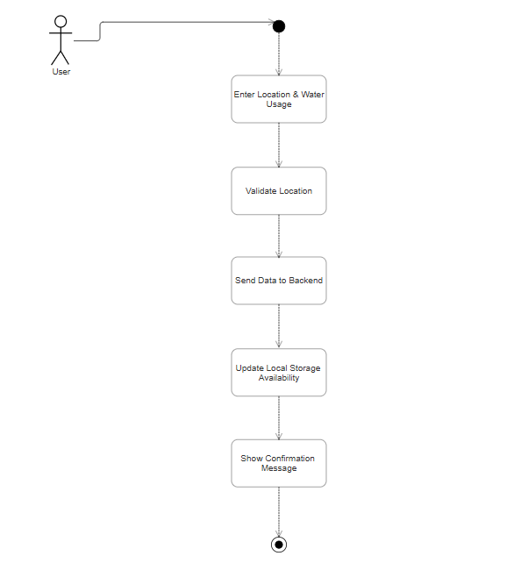

Admin Activity:

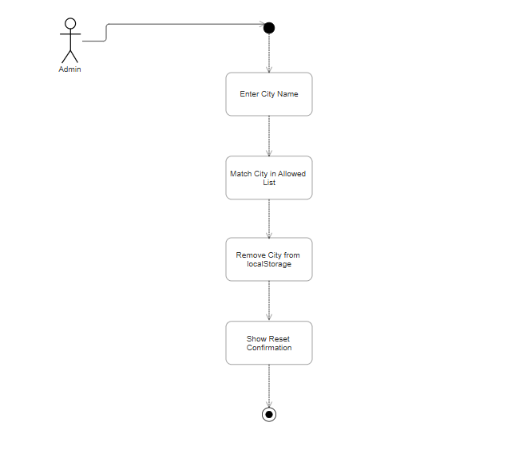

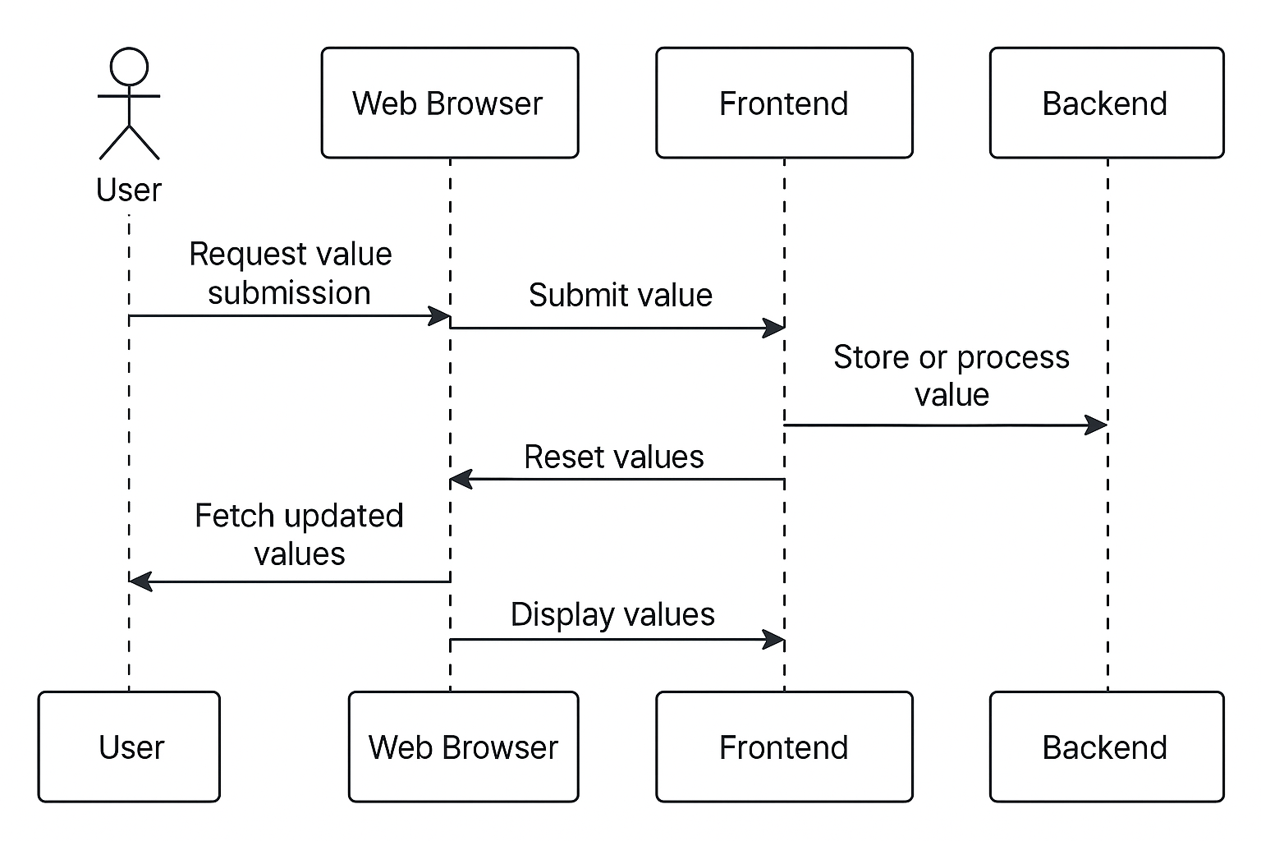4.Sequence Diagram:

5.System-Level UML Diagram:

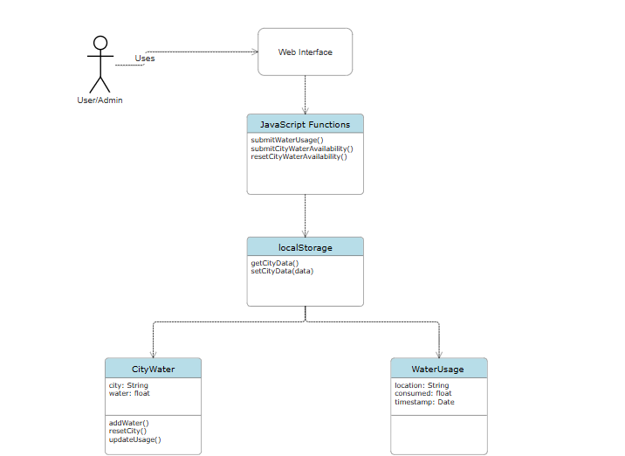

**Modules of the Project:**

**1.User Module:**

1. Enables one to enter the amount of water usage for one's own city.
2. Verifies the city name and quantity of water used.
3. Updates the data on available water accordingly.

**2.Urban Water Management Module:**

1. Allows the input and modification of cumulative water availability for different urban zones.
2. Facilitates water data reset for a city to start the availability from scratch.
3. Stores and maintains city-wise water data using local storage (or database in backend integration).

**3.Dashboard Module:**

1. Indicates the present water availability condition of all cities.
2. Offers information in user-friendly and illustrative format.
3. Auto-update based on recent submissions or resets.
4. Module for Validation and Error Management Confirms that all fields entered have been filled correctly.
5. Processes incorrect or invalid city names, negative or zero water amounts, etc.
6. Provides the user with appropriate feedback and alerts.

**4.Data Persistence Module:**

1. Stores data locally (or database if backend is implemented) to retain data between page reloads.
2. Updates and retrieves dynamically stored water data.
3. Ensures that data flows smoothly between different pages (e.g., submit.html and cities.html).
4. Navigation Component Manages internal page navigation (i.e., Dashboard, Cities, About, Contact). Provides a smooth and natural interface experience with clean page transitions.

**Code’s**

**Frontend code’s:**

**1. index.html (Dashboard)**

* This is the **homepage** of the project.
* Provides a general overview or welcome screen.
* 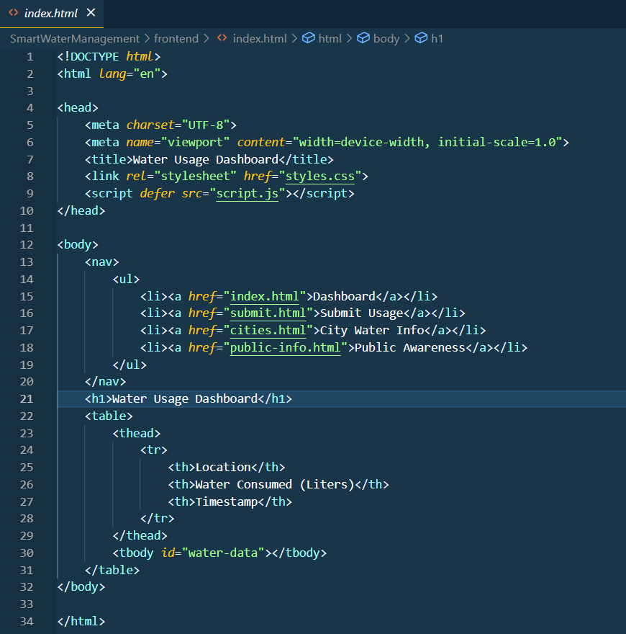Contains links to other pages (Cities, Submit, About, Contact).

**2. submit.html (Submit Usage & Availability):**

* Page where users can:
* Submit their **water consumption** by city.
* Enter or **reset total water availability** for a city.
* Includes submitWaterUsage() and resetCityWaterAvailability() functions.
* Stores data in **local Storage** or sends to backend.

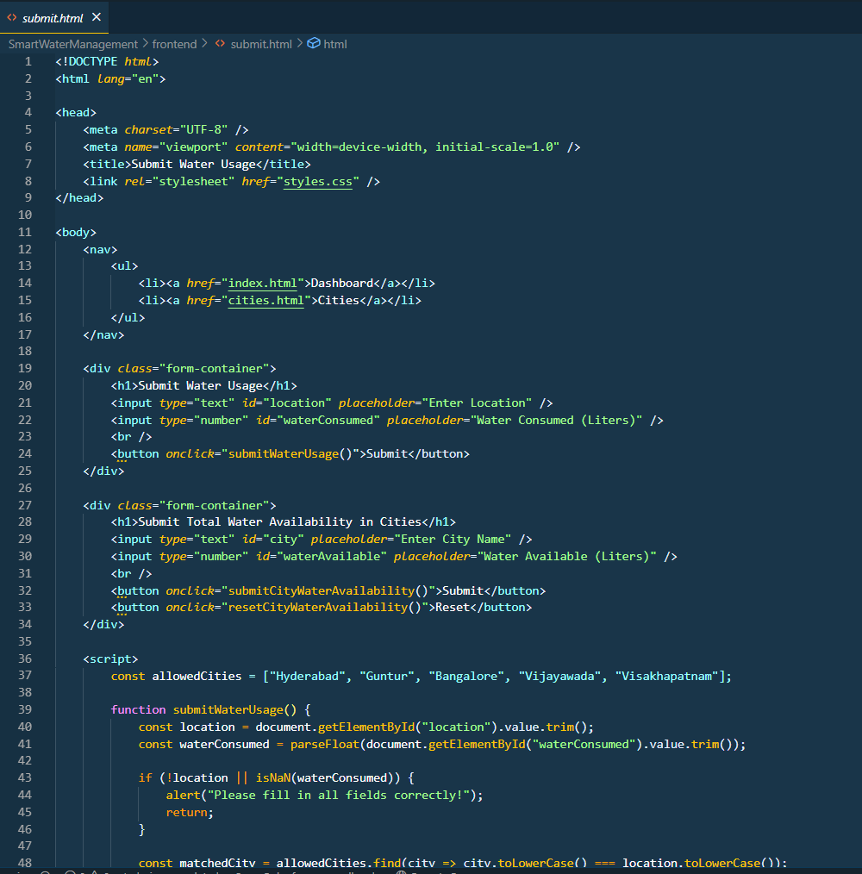

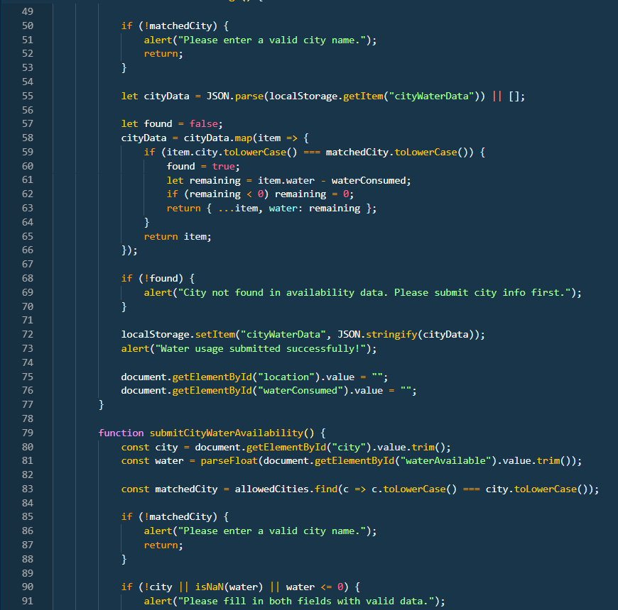

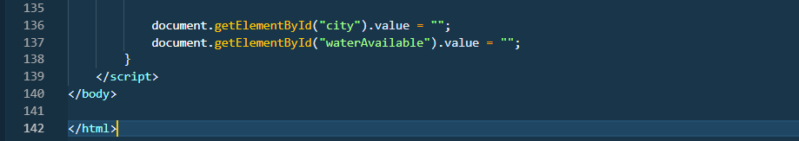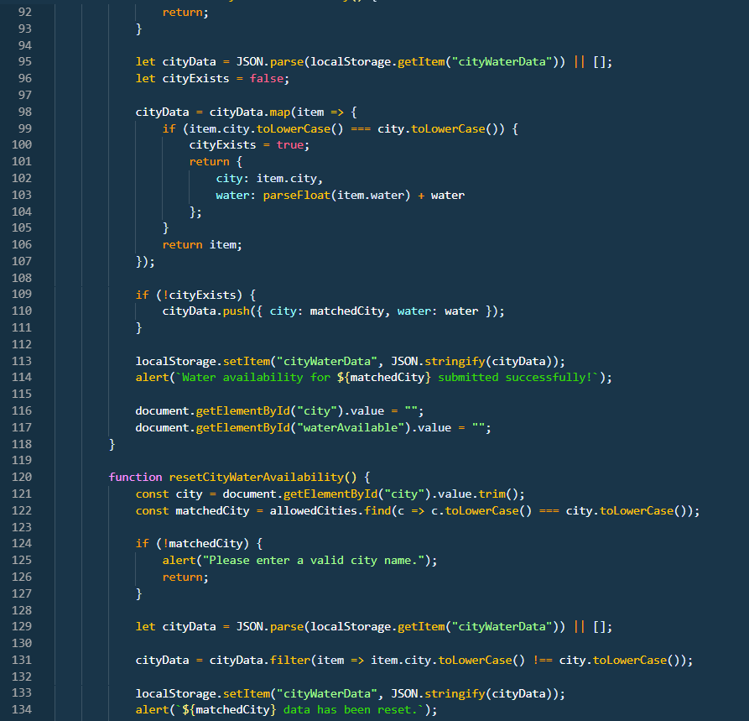

**3. cities.html (City Water Info):**

* Displays the **current water availability** for each city.
* Pulls updated data from localStorage.
* Reflects real-time updates from submit.html.

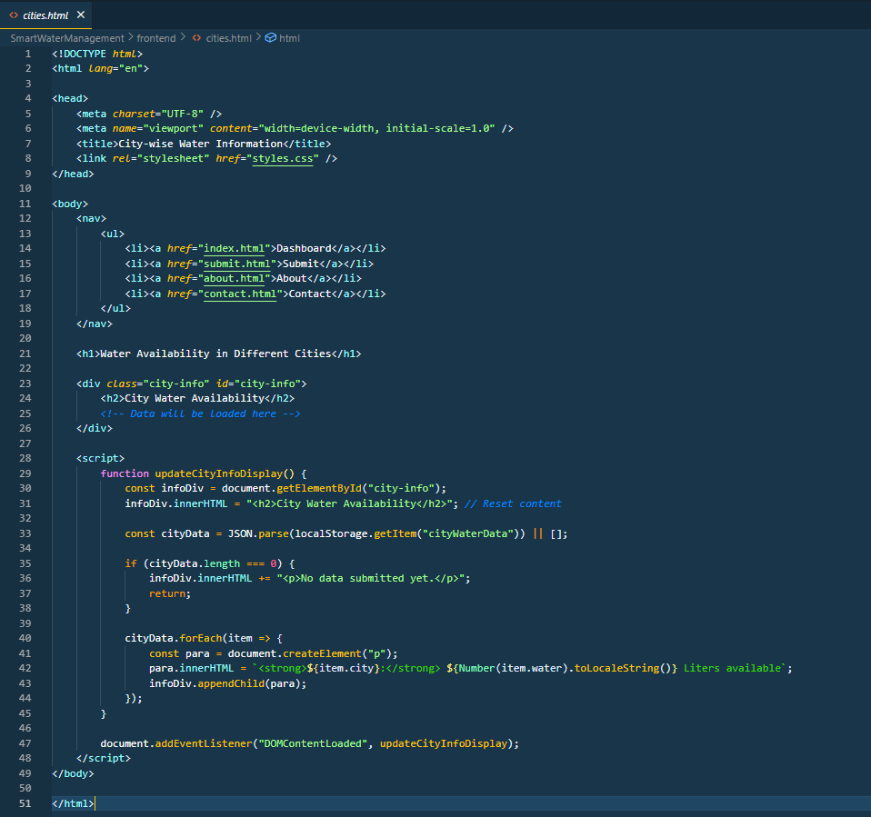

**4.Public info.html:**

* Displays the **current water availability** for each city to Public.
* Pulls updated data from localStorage.
* Reflects real-time updates from submit.html.

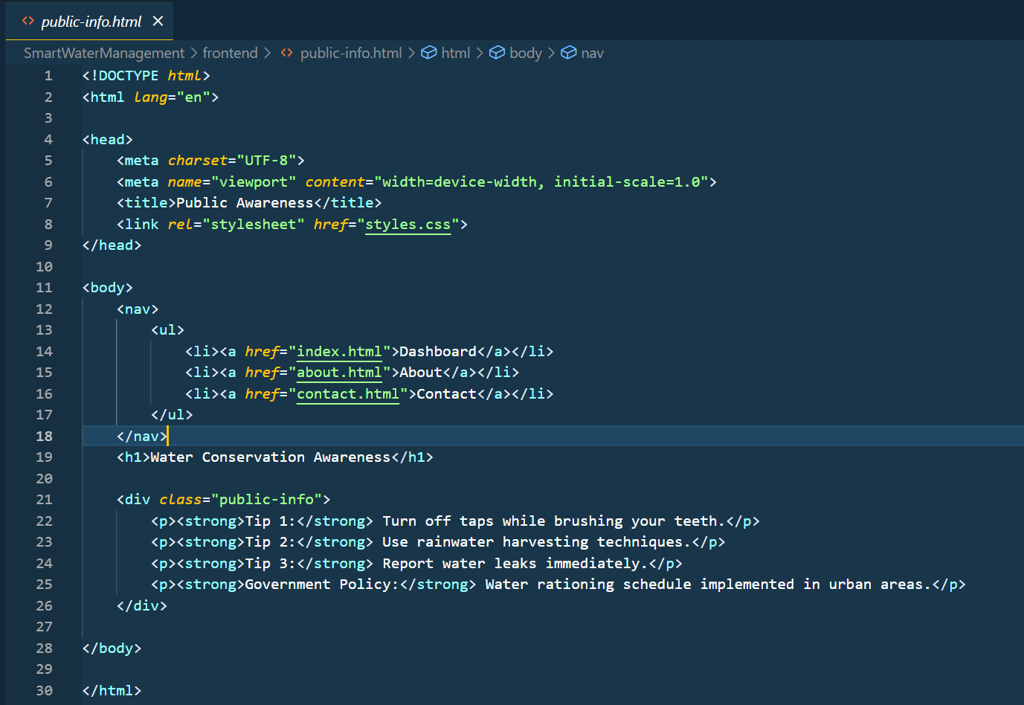

Styles.css:

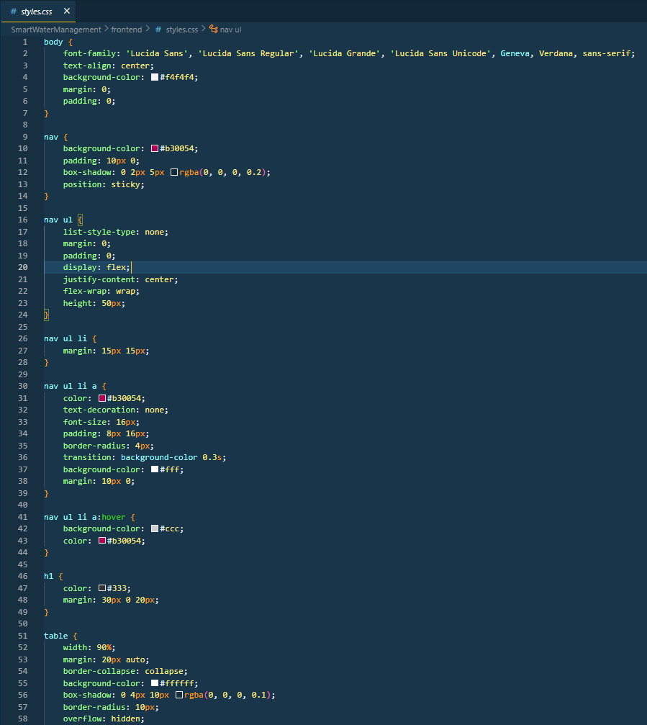

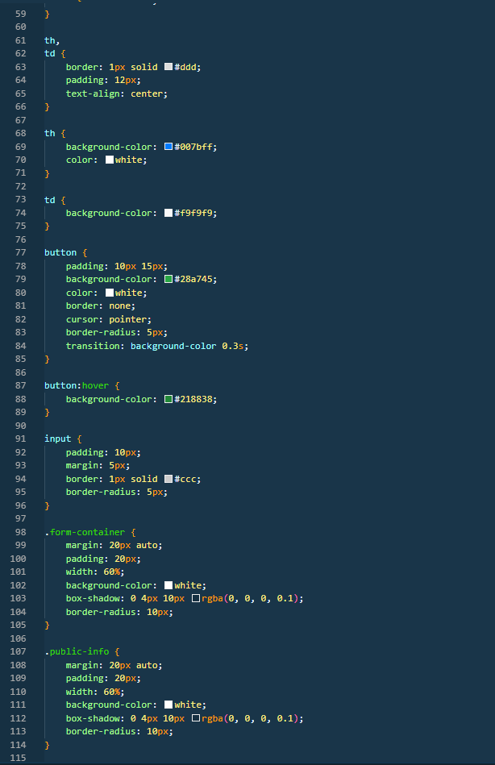



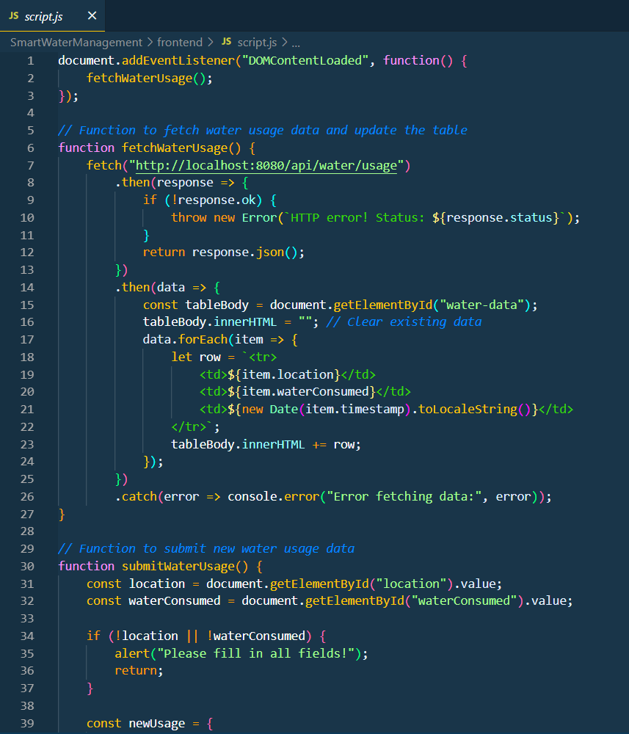Script.js:

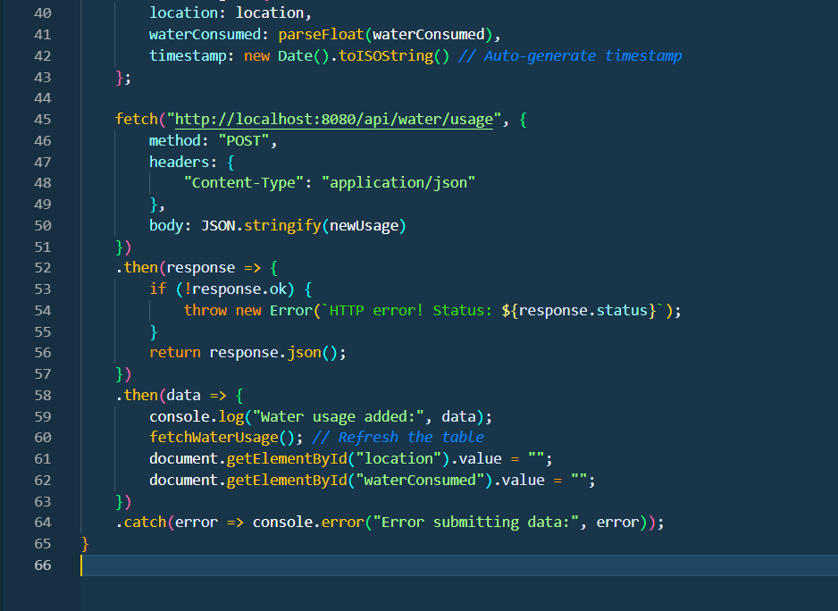

Backend Code’s by Java:

Controllers/WaterUsageController.java:

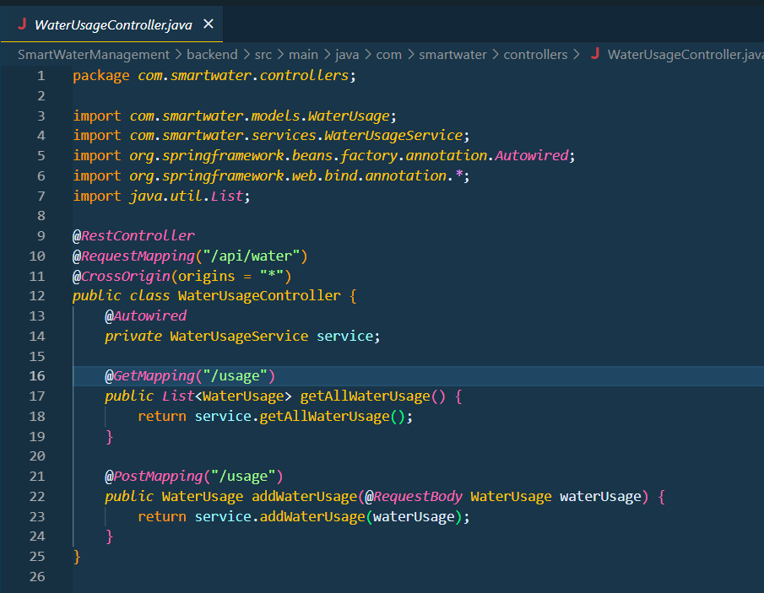

Repository/WaterUsageRepository.java:

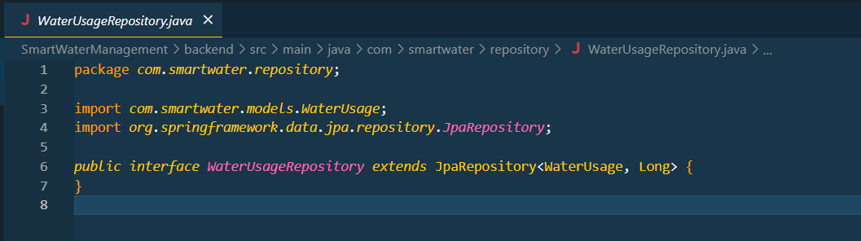

Models/WaterUsage.java:

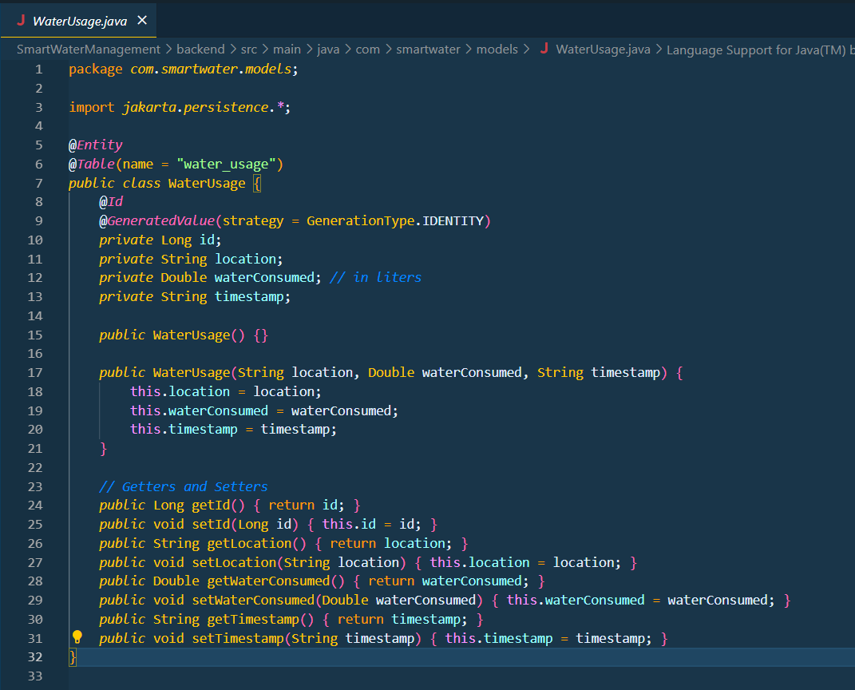

Services/WaterUsageService.java:

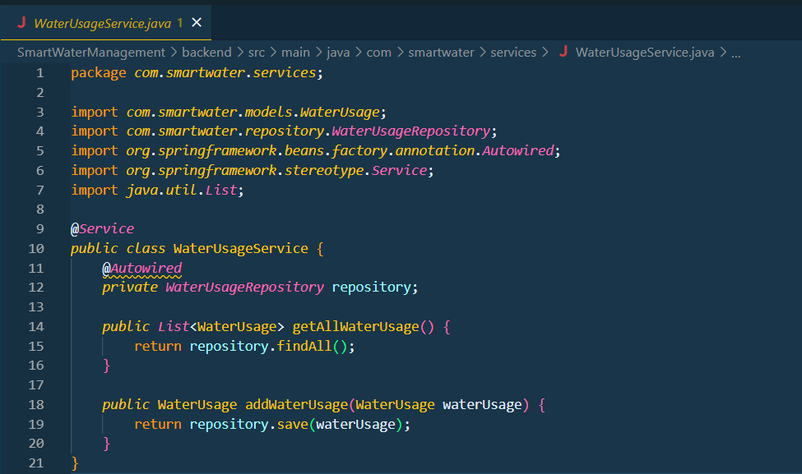

Services/WaterManagementApplication.java:

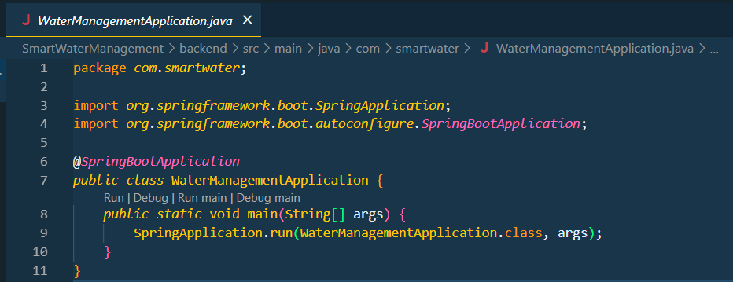

Classes/

Controllers/WaterUsageController.class:

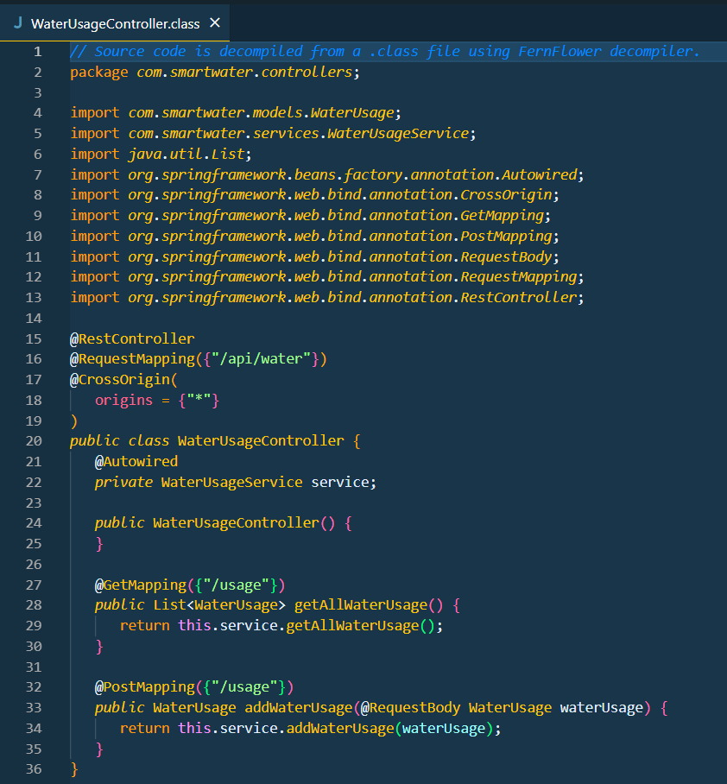

Models/WaterUsage.class:

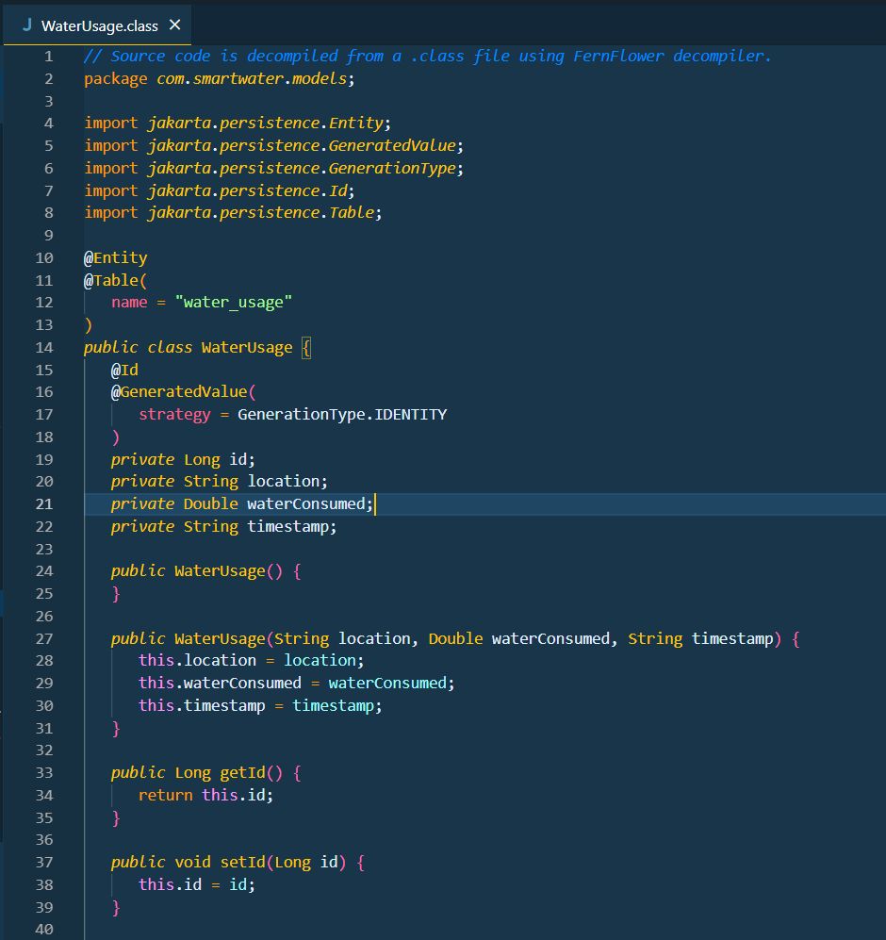

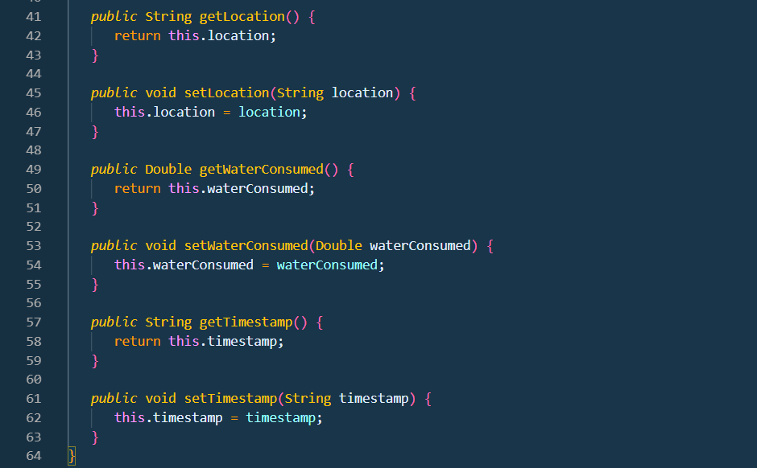

Repository/WaterUsageRepository.class:

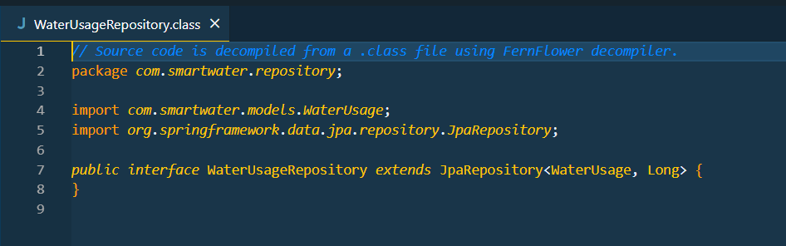

Services/WaterUsageService.class:

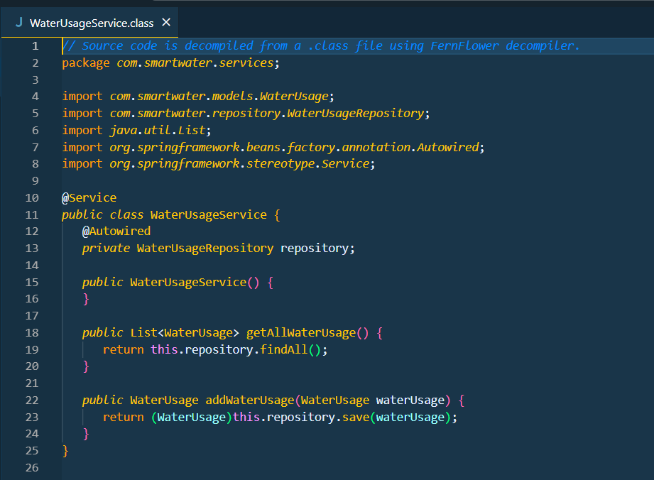

Services/WaterManagementApplication.class:

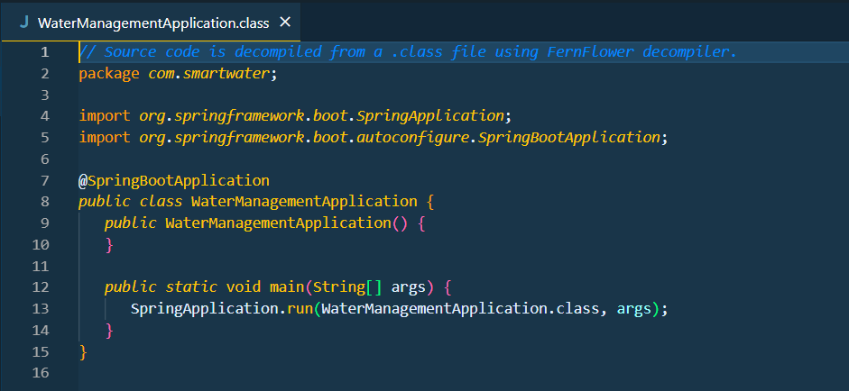

Outputs of the Project:

Index.html:

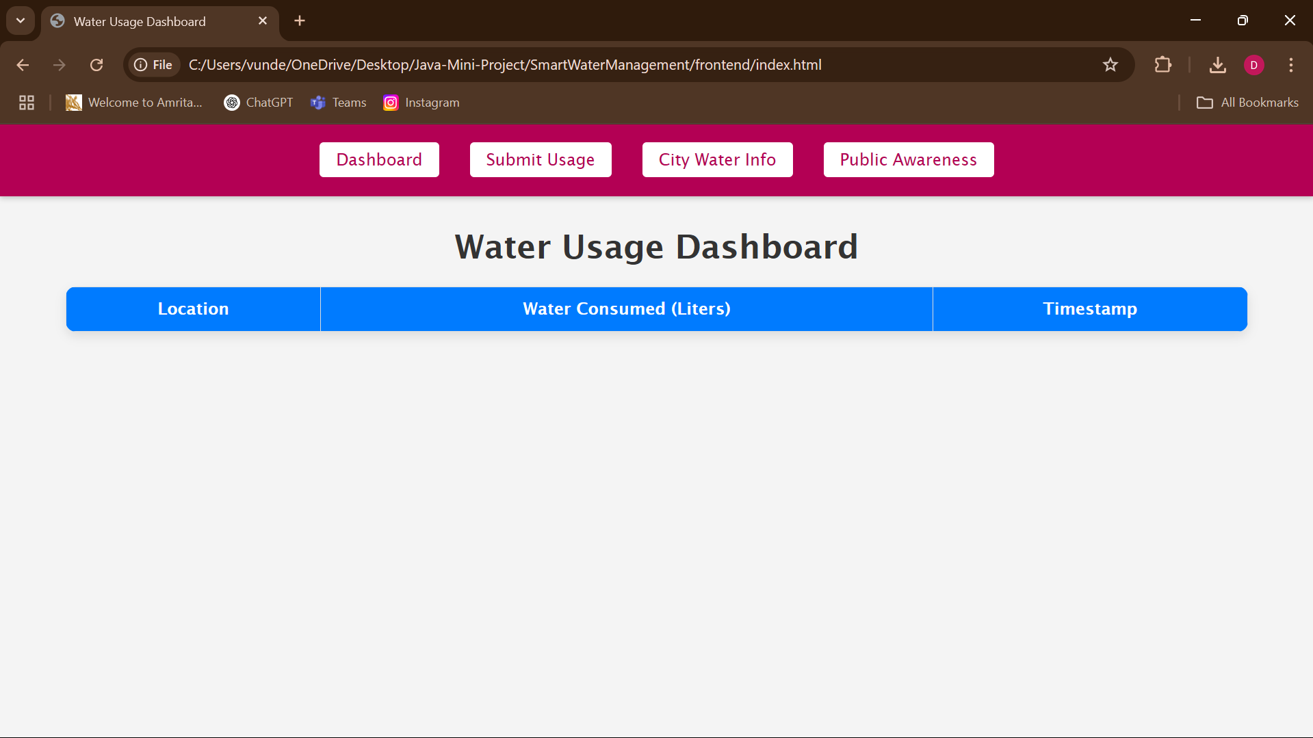

Submit.html:

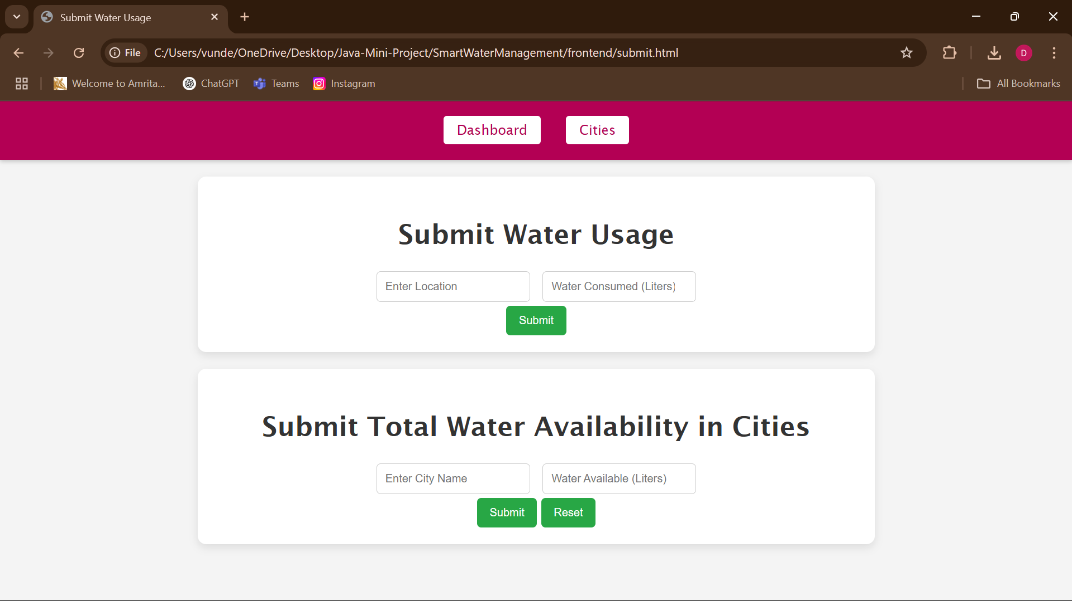

After Submitting the Total Availability in Cities:

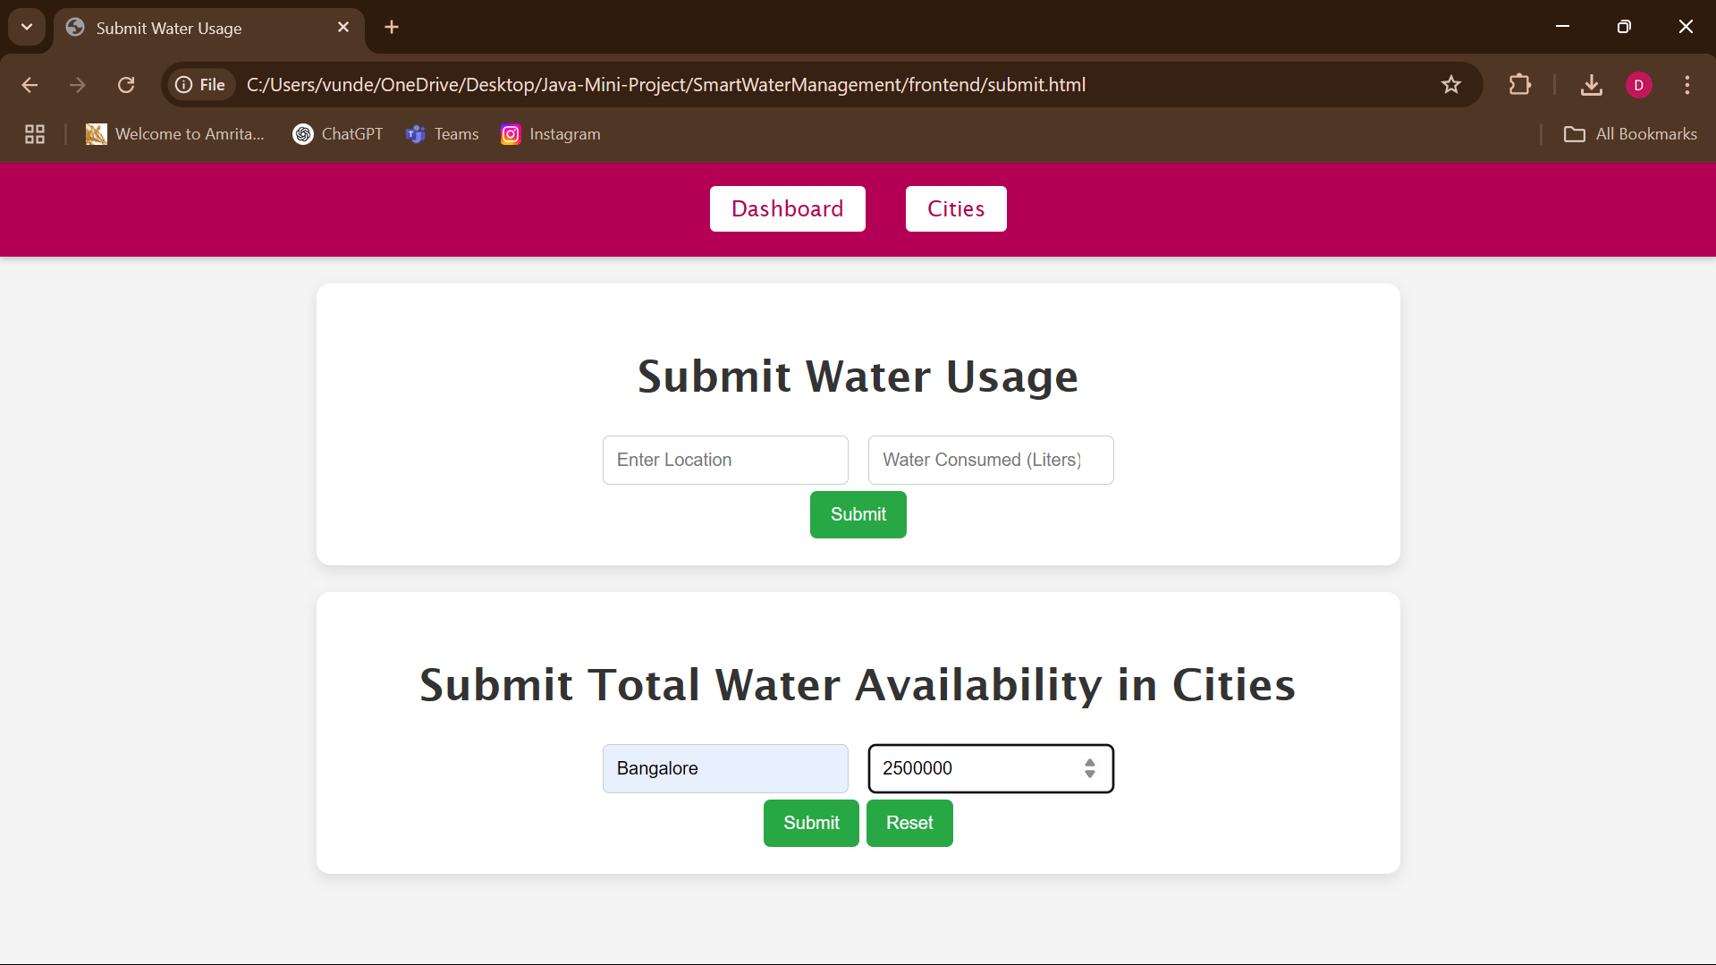

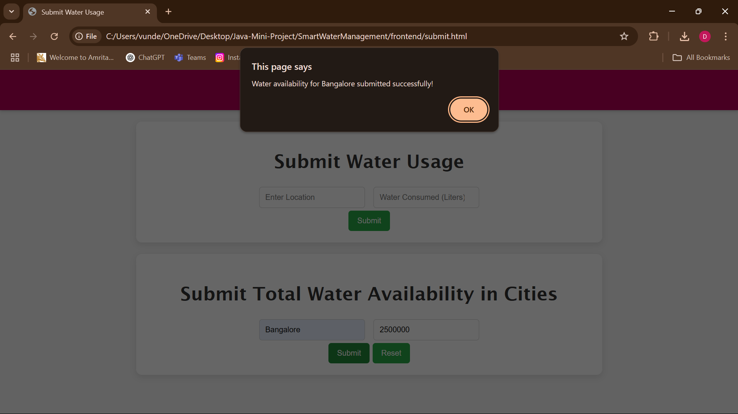

After Submitting in the submit page it will push the data into the cities.html with the admin entered data:

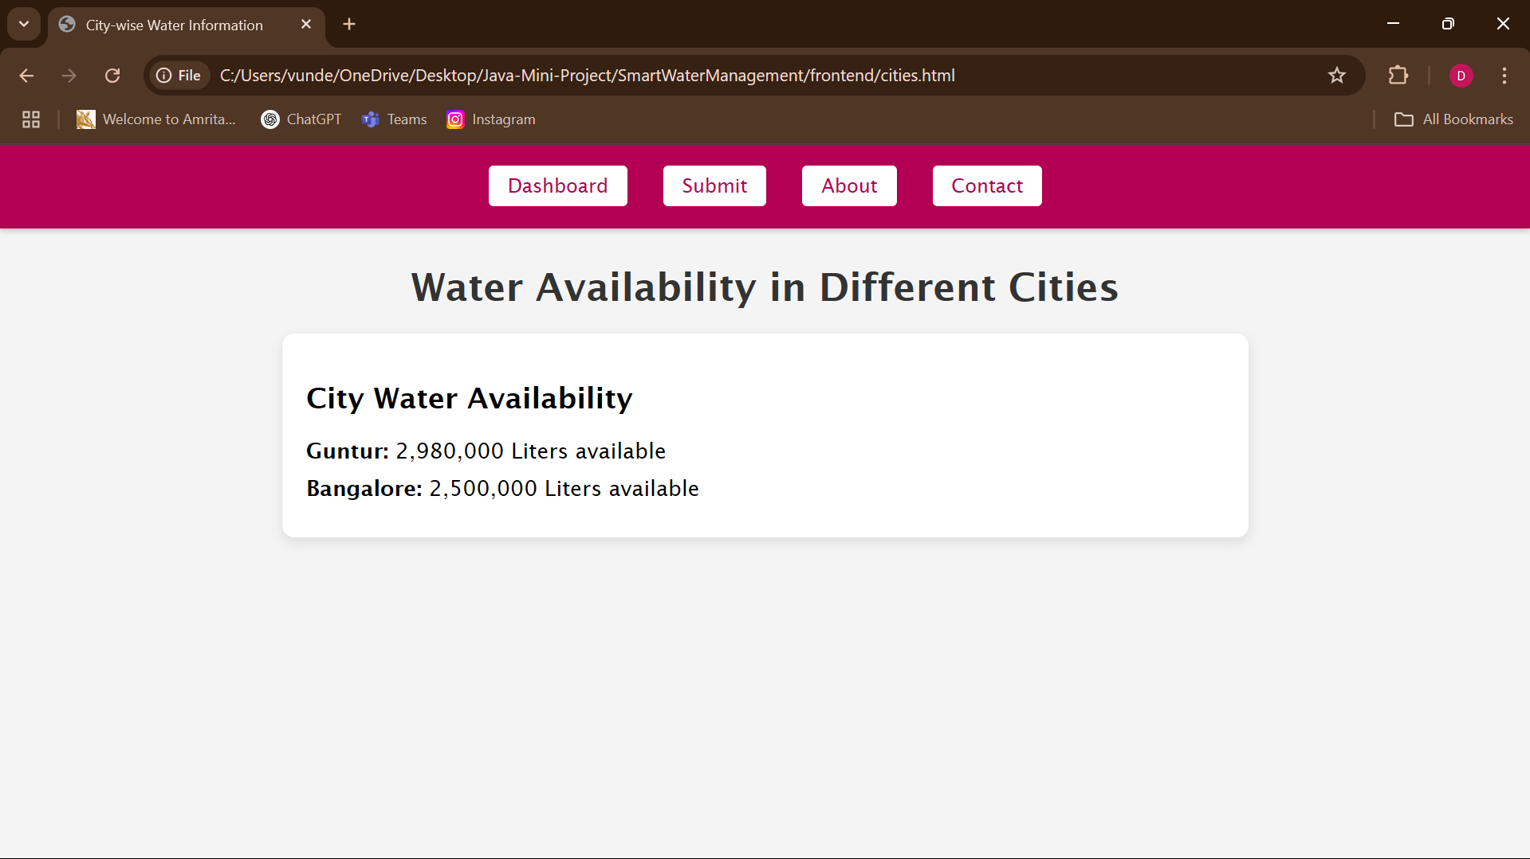

Submitting the user that consumed water in the submit.html:

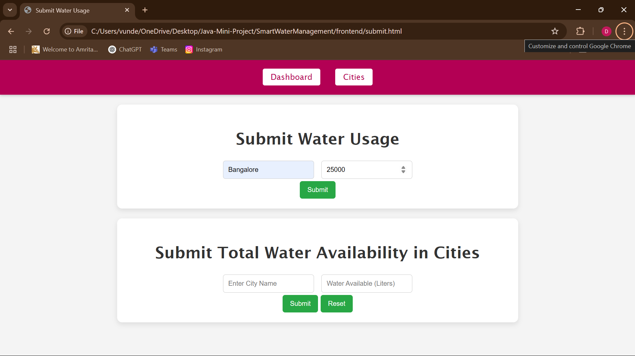

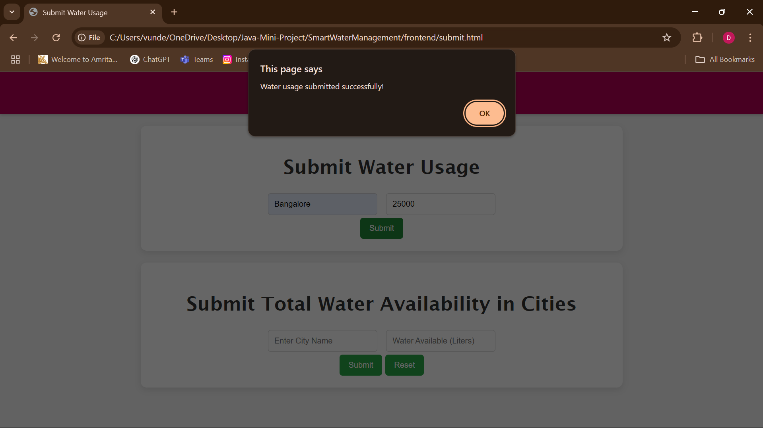

It will reduce the amount of water for the total amount of present in that particular city:

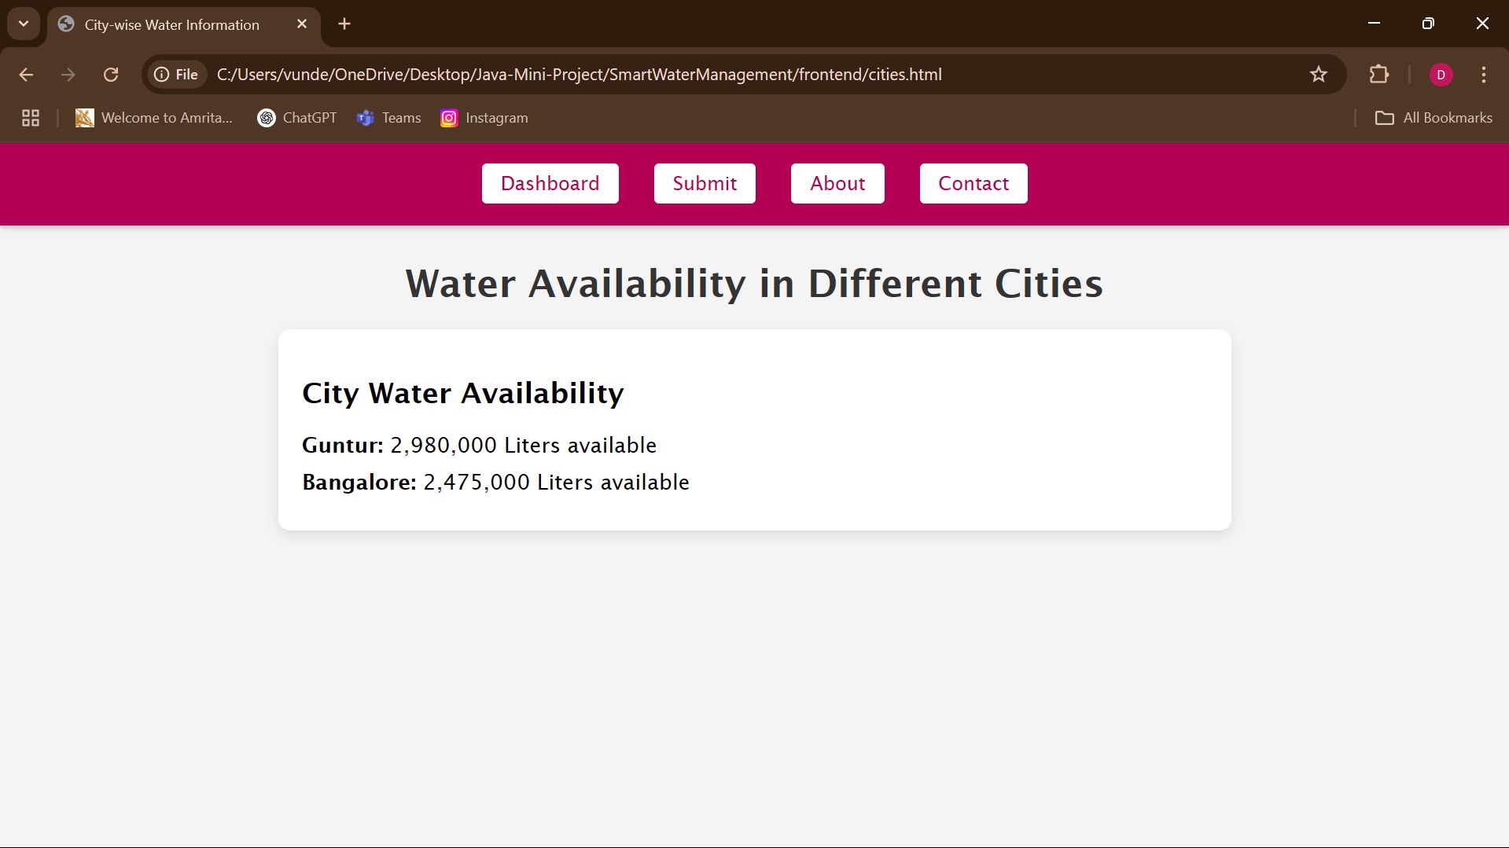

Public-info.html:

